Contents
1. Zoom: Overview: 1
2. Requesting Zoom Meeting: 1
3. Zoom – Free Account: 1
4. How to Join a Zoom Session as a Participant. 1
5. How to Join a Zoom Session as a Host. 1
6. Security: 1
7. Advanced Settings: 1
8. Pro Tips: 1
9. References: 1

Zoom: Overview:
Zoom is an online web resource that allows users to collaborate though video conferencing and sharing desktop resources. The instructions herein are a primer for joining a meeting hosted by someone else and how to host small meetings. If there is a need to host a meeting for more than a few participants, please notify Helpdesk (x429) or System Administrator for assistance.
The firm has a paid Zoom account for large group meetings or webinars. You, as an individual user, also have the option of signing up for a free Zoom. Zoom software is already installed in the taskbar of the Canton Conference Rooms (CR-K, CR-W, CR-G, CR-D, CR-1). Just click on the Zoom icon to get started.
NOTE: Please login to Zoom from your LOCAL PC or laptop. Do not attempt to use this through Terminal Server as the he quality of your meeting and response time will be affected.
NOTE: Each Host account can only run one (1) meeting at a time. Meetings using the same login cannot overlap.

Requesting Zoom Meeting:
At this time, KWGD has several Zoom accounts for hosting multiple meetings at the same time. The Firm Zoom accounts can accommodate up to 100 attendees each. HOWEVER: Each account can only accommodate one meeting at a time. Scheduling meetings in advance is highly encouraged for longer meetings to avoid conflicts. Please contact your respective Zoom Administrator to make an appointment and they will send you the meeting information.
- Sam Vongratana: Firmwide
- Holly Axline: Corporate
- Audrey Tasseff: Estate Planning/Elder Law
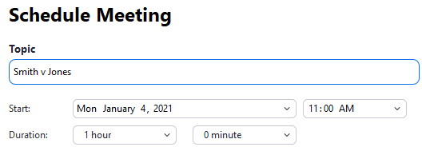
Please provide:
- Meeting name: i.e. Smith v Jones, topic or your initials at a minimum.
- Date: Start time
- Duration of the meeting closest quarter hour. (i.e. 1 hr, 1.25hr, 90 min)
Zoom Admins will check for conflicts, schedule the Zoom meeting. An Outlook meeting invite will be sent to whoever requested it. The requester can then send out or forward the meeting information to all attendees. Consider in your request:
- Is this in a real Conference Room that needs setup and if so, which one?
  - NOTE: CR-G is best for 1-2 physical people due to its table layout. 4 or more should consider the other Conference Rooms.
  - CR 5 and 7 are setup for single attendee/close-up. Preferable for hearings, depositions and court appearances.
- For security purposes, all meetings are password protected and included with all email invite.
- By default, Zoom meetings are Computer Audio only. There is an option for phone + computer audio, but anyone using the phone option may be charged a long distance fee.

Zoom – Free Account:
Zoom free accounts are available if you supply an email address. Free account is good for small, one-on-one (or two) meetings or meetings with multiple participants that are capped at 40 minutes. Simply go to the website below and enter your email to register for an account.
www.zoom.us

How to Join a Zoom Session as a Participant.
You do not need a free or paid account to join as a participant.
- Open a browser and go to www.zoom.us. Click on the Join button at the top of the screen.


  - Or: if you are in one of the CR-K, CR-W, CR-G, CR-D or CR-1 Conference Rooms in Canton, click on the Zoom icon pinned in the Taskbar.
- Enter the meeting number. This should be a 9 digit number. You do not have to type the dashes. This comes from the Host Organizer, usually in an email invitation.
  - NOTE: If you have a HOST KEY, you can take over the meeting for Host if they have not arrived. Click on Participant > Claim Host. Enter the 6 digit Host Key.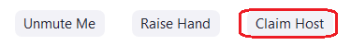
- Move the mouse or tap the space bar to display the Zoom toolbar. If the Microphone or the Camera icons are red, they are not transmitting. The other participants cannot hear/see you. If you want to activate/deactivate the microphone or camera at any time, simply click on the respective icon.

How to Join a Zoom Session as a Host.
Free or paid account is required to Host a meeting.
- Open a browser and go to www.zoom.us. Or if you are in one of the CR-K, CR-W, CR-G, CR-D or CR-1 Conference Rooms in Canton, click on the Zoom icon pinned in the Taskbar.
- Click on the Host button at the top of the screen.
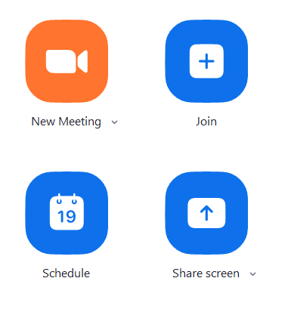
- Click the SIGN IN button and follow the onscreen prompts.
- On the HOME tab, select New Meeting to start the meeting, or Schedule if the meeting was previously scheduled. If you are scheduling a meeting these are the recommended settings:
  - Generate the Meeting ID
  - Randomly create a Password for the meeting. Do not start a meeting without a password.
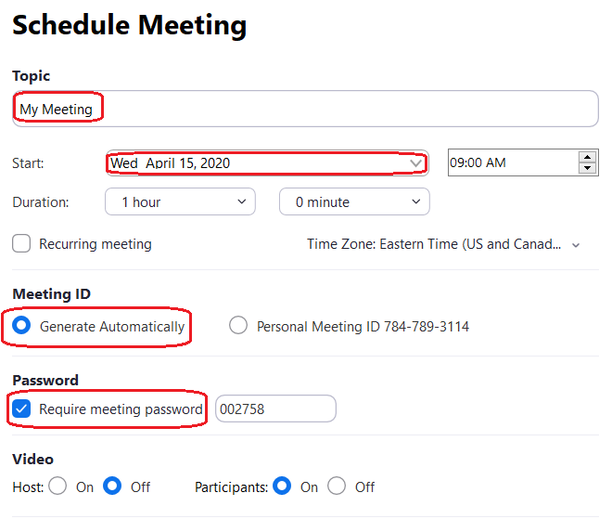
  - Use Computer Audio only. In the case you need to use a telephone, do not use the phone numbers Zoom provides. They are long distance and not necessarily secure, as they are known numbers.
  - NOTE: Volume is controlled by the TV remotes in Canton Conference Rooms. Volume control on personal laptops can be found in the lower right by the computer clock.

- Zoom toolbars will automatically hide themselves to provide additional view space. Move the mouse or tap the keyboard space bar to display the Zoom toolbar again. If the Microphone or the Camera icons are red, they are not transmitting. The other participants cannot hear/see you. If you want to activate/deactivate the microphone or camera at any time, simply click on the respective icon.
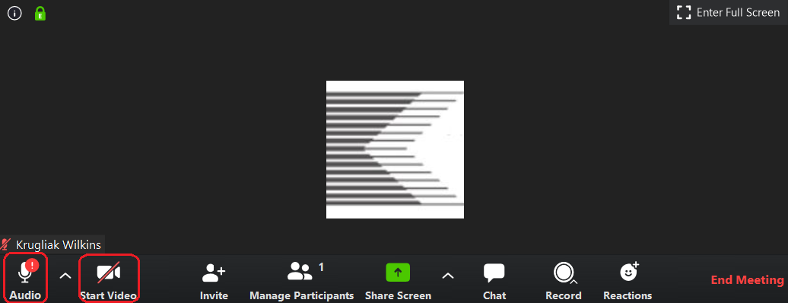

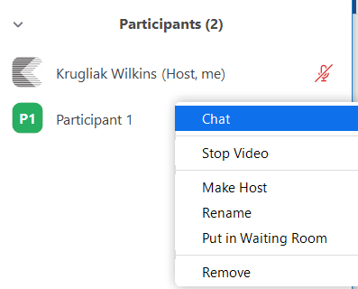
- Manage Participants shows how many attendees there are. Clicking this button shows the names of the attendees. Hosts have several options with attendees by clicking on the MORE button:
  - Turn Audio/Video on and off for the attendee.
  - Make Host – Gives the attendee Host control of the meeting.
  - Put in Waiting Room – Temporarily removes the user from the Meeting.
  - Remove – Kicks the attendee out of the meeting. Removed Participants cannot rejoin.
- Share screen allows you to share any electronic resources on the current computer with other attendees. Used in document collaboration type meetings.
  - NOTE: Zoom has a whiteboard option though Share Screen that allows you to draw, similar to a white board.
- Chat is used when all participants are muted except the presenter but still allows for text communication. This is for Webinar type meetings Where everyone except the Presenter is muted.
- Full screen toggle in the upper right corner us used to switch between Full Screen mode and viewing the desktop. As long as the Share Desktop is not on, you can view items next to the Zoom window.

Security:
If you are creating your own meeting, please generate a NEW meeting room number and password. Do not use the Personal Meeting ID (PMI) number.

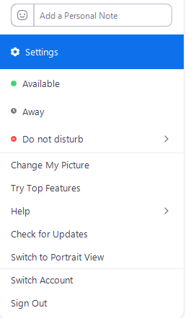
Advanced Settings:
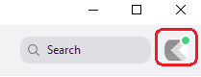
Now that you are more familiar with Zoom, the following are recommended default settings. Once these settings are saved, they will apply to all future meetings scheduled or generated. HOWEVER, you will have to review and edit any pre-existing meetings that were created before these settings were changed.
- Click on your account icon. This is the square in the upper right corner next to Search.
- Select Settings from the menu.
- From the menu, you can personalize settings. The following are the suggested standard settings.
  - Use Dual Monitors
  - Remind me defaults to sending a notification 5 min before a meeting starts. For client meetings or meetings with a large number of people 15 min is recommended to address any technical issues so that the meeting starts on time.
- Additional account settings can be found by clicking View More Settings. This open a browser, where you login again to access Advance Settings. Recommended settings set here will set the defaults going forward for any device using this login.
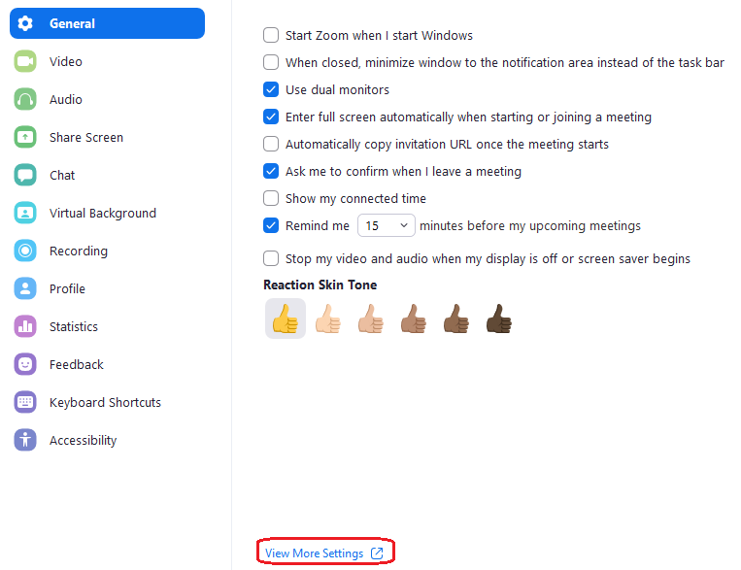
  - Enable Join Before Host = On
  - Allow Co-Host = On
  - Breakout Room = On
  - Join from Browser Link = On
  - Host Key (Set to any 6 digit number)

Pro Tips:
- If you are using a webcam or laptop: Consider lifting/propping it up higher. Looking down onto a laptop or camera gives some people a “double chin”. You visually present better visually if you are looking across or up at your camera/screen.
- Be aware of the distance to the screen/camera. Some people lean into the laptop excessively, creating a “big head” visual. Try to sit up/back and relax.
- Be aware if your surroundings: Bright light behind you can “white out” and distort your video. Also be aware of ambient noise that can cause distractions to other participants (i.e. animals, kids, construction outside your work area)
- Zoom also has an iPhone app. You are not limited to using a laptop or Conference Room. But if you use the phone app, be aware of your surroundings. Try to keep a wall behind you. (Funny meetings goofs made in the background sometimes end up on the internet for entertainment.)

References:
Protecting Yourself and Others on Zoom: https://office-watch.com/2020/protecting-yourself-and-others-on-zoom/?utm_medium=Email&utm_source=ofmm
More Zoom Features and How to Use Them: https://www.maketecheasier.com/zoom-features-for-better-remote-meetings/?utm_source=newsletter&utm_medium=email&utm_campaign=31032020

